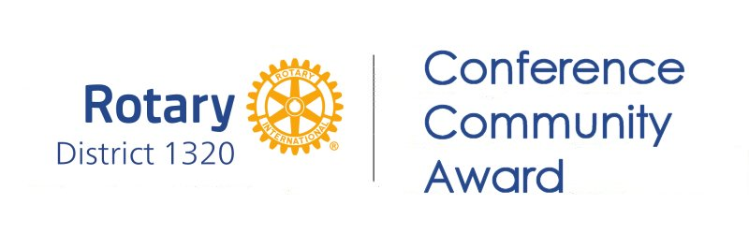

Conference 2026 - Community Award Scheme

Is your club sending delegates to Conference 2026?

Do you have a project that would benefit from the addition of £1000.00?

Only clubs that have delegates attending conference may enter.

Why not give it a go?

If you’re not in, you cant win!

DG Brenda, is keen to ensure that as many clubs as possible have the opportunity to prepare an application, to present to conference, in order that a real, tangible benefit, returns from conference to your clubs community.

The format of the competition will require individual clubs to provide details of their proposed community based project. The winning club voted for from a shortlist of 4 entries at the District Conference at the Normandy Hotel, will receive a cheque for £1000.

The project must be community based, within the catchment area of the winning Rotary club/s for joint applications.

Time line

Please provide details of your project on the enclosed application form and return it to;
Jim Hettrick at email jim.hettrick@btconnect.com By no later than 16th January 2026.

By 2nd February 2026 a short list of 4 clubs will have been selected to present their project at the District Conference on Sunday 15th March 2026. The short list applications will be selected by a panel of judges from District 1190, NW England.

The Rotary Club of Annan as DG Brenda’s home club, has excluded itself from the competition.

The final four clubs seleted to present, will be notified not later than 5th February 2026 to allow time for the preparation of a short presentation max 4 mins, to be delivered at conference. Powerpoint presentations will require to be with the conference IT specialist, not later than Monday 2nd March 2026.

The winning entry will be selected by the conference delegates at the session on Sunday morning, a simple majority wins.

The community project may be a new project or a positive extension of an existing project.

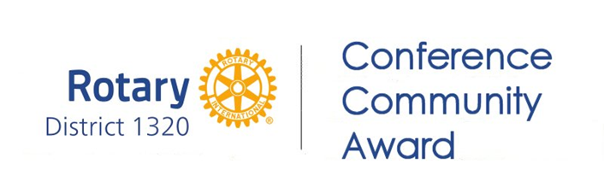

Project Content

Applications for entry to the competition should be completed on the enclosed form. The project outline should be able to demonstrate the overall benefits to the community both short and medium term. The project should ideally be able to demonstrate the working involvement of club members and potential community partners.

Photographic evidence if available showing the scope of the work should be enclosed with the application.

The award may be carried forward as a part of a match funding grant application into the Rotary year 2026/2027.

On completion of the project, a feedback analysis should be prepared and forwaded to,
jim.hettrick@btconnect.com, in order that all clubs may then be advised through the medium of the weekly News for Clubs.

